**ALL PYRAMID PATTERN AND NUMBERS ;**

**In java**

Q. 3: Number Pattern14

QUESTION DESCRIPTION  
  
Write a program to print following outputs.  
1010101  
0101010  
1010101  
0101010  
1010101  
0101010  
1010101

**Code:**

**import java.util.Scanner;**

**public class TestClass**

**{**

**public static void main(String[] args)**

**{**

**Scanner sc = new Scanner(System.in);**

**int rows = sc.nextInt();**

**for(int i = 1; i <= rows; i++)**

**{**

**int num;**

**if(i%2== 0)**

**{**

**num = 0;**

**for(int j = 1; j <= rows; j++)**

**{**

**System.out.print(num);**

**num = (num == 0)? 1: 0;**

**}**

**}**

**else**

**{**

**num = 1;**

**for(int j = 1; j <= rows; j++)**

**{**

**System.out.print(num);**

**num = (num == 0)? 1: 0;**

**}**

**}**

**System.out.println();**

**}**

**sc.close();**

**}**

**}**

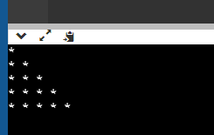

**Program :**

**#include <iostream>**

**using namespace std;**

**int main()**

**{**

**int num =5;**

**for(int i = 1; i<=num; i++)**

**{**

**for( int j = 1 ; j<=i; j++)**

**{**

**cout<<"* ";**

**}**

**cout<<endl;**

**}**

**return 0;**

**}**

**Program for inverse;**

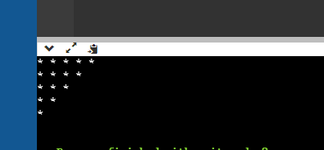

**Program ;**

**#include <iostream>**

**using namespace std;**

**int main()**

**{**

**int num =5;**

**for(int i = num ; i>=1; i--)**

**{**

**for( int j = 1 ; j<=i; j++)**

**{**

**cout<<"* ";**

**}**

**cout<<endl;**

**}**

**return 0;**

**}**

**ANOTHER PROGRAM ;;**

**#include <iostream>**

**using namespace std;**

**int main()**

**{**

**int num =5;**

**for(int i = 1; i<=num; i++)**

**{**

**for( int j = i ; j<=num; j++)**

**{**

**cout<<"* ";**

**}**

**cout<<endl;**

**}**

**return 0;**

**}**

**Numbers pattern ;**

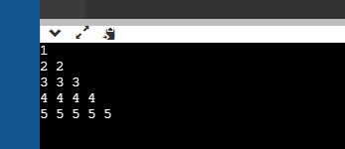

**Program ;**

**#include <iostream>**

**using namespace std;**

**int main()**

**{**

**int num =5;**

**int print = 1;**

**for(int i = 1; i<=num; i++)**

**{**

**for( int j = 1 ; j<=i; j++)**

**{**

**cout<<print<<" ";**

**}**

**print++;**

**cout<<endl;**

**}**

**return 0;**

**}**

**Another program ;**

**#include <iostream>**

**using namespace std;**

**int main()**

**{**

**int num =5;**

**for(int i = 1; i <= num; i++)**

**{**

**for( int j = 1 ; j <= i; j++)**

**{**

**cout<<i<<" ";**

**}**

**cout<<endl;**

**}**

**return 0;**

**}**

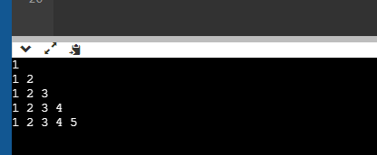

**Program ;**

**#include <iostream>**

**using namespace std;**

**int main()**

**{**

**int num =5;**

**for(int i = 1; i <= num; i++)**

**{**

**for( int j = 1 ; j <= i; j++)**

**{**

**cout<<j<<" ";**

**}**

**cout<<endl;**

**}**

**return 0;**

**}**

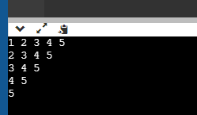

**Program;**

**#include <iostream>**

**using namespace std;**

**int main()**

**{**

**int num =5;**

**for(int i = 1; i <= num; i++)**

**{**

**for( int j = i ; j <= num; j++)**

**{**

**cout<<j<<" ";**

**}**

**cout<<endl;**

**}**

**return 0;**

**}**

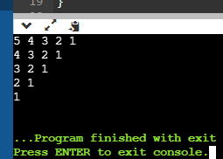

**Program ;**

**#include <iostream>**

**using namespace std;**

**int main()**

**{**

**int num =5;**

**for(int i = num ; i >= 1 ; i--)**

**{**

**for( int j = i ;j>=1; j--)**

**{**

**cout<<j<<" ";**

**}**

**cout<<endl;**

**}**

**return 0;**

**}**

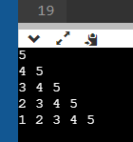

**Program ;**

**#include <iostream>**

**using namespace std;**

**int main()**

**{**

**int num =5;**

**for (int i = num ; i >=1 ; i--)**

**{**

**for(int j = i ; j<=num; j++)**

**{**

**cout<<j<<" ";**

**}**

**cout<<endl;**

**}**

**return 0;**

**}**

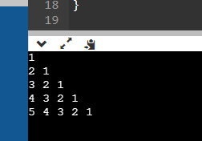

**Program ;**

**#include <iostream>**

**using namespace std;**

**int main()**

**{**

**int num =5;**

**for (int i = 1 ; i <=num ; i++)**

**{**

**for(int j = i ; j >=1; j--)**

**{**

**cout<<j<<" ";**

**}**

**cout<<endl;**

**}**

**return 0;**

**}**

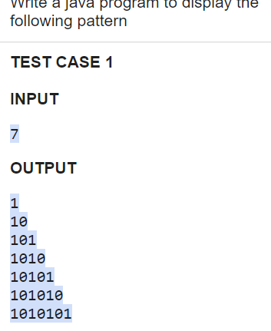

**Program;**

**import java.io.*;**

**import java.util.Scanner;**

**public class TestClass**

**{**

**public static void main(String[] args)**

**{**

**Scanner sc = new Scanner(System.in) ;**

**int num= sc.nextInt();**

**int sum=0,i,j;**

**for(i = 0; i <=num; i++)**

**{**

**if(i==num)**

**{**

**break;**

**}**

**for(j = 0; j <=i; j++)**

**{**

**if(j % 2 != 0)**

**{**

**System.out.print("0");**

**}**

**else**

**{**

**System.out.print("1");**

**}**

**}**

**System.out.println();**

**}**

**}**

**}**

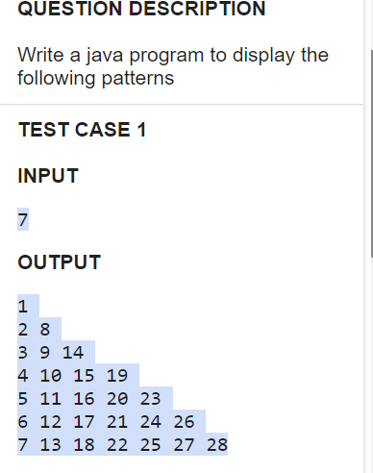

**Program ;**

**import java.io.*;**

**import java.util.Scanner;**

**public class Main**

**{**

**public static void main(String[] args)**

**{**

**Scanner s = new Scanner(System.in);**

**int num = s.nextInt();**

**for(int i = 1; i<=num; i++)**

**{**

**int num1 = i;**

**for(int j = 1 ;j<=i ; j++)**

**{**

**System.out.print(num1+" ");**

**num1 = num1 + num - j ;**

**}**

**System.out.println();**

**}**

**}**

**}**